Experiment Number : 8 Date: 25.02.2026

Implementation of Packages in Java

Aim:
Write a Java program to implement built-in, user-defined packages and accessing all classes in a package.

PRE LAB EXERCISE
QUESTIONS
- What is java.util package and what collection framework does it contain?
java.util package:
- It is a predefined package in Java that provides utility classes.
- It contains classes for data structures, date & time, random numbers, and string handling.
- It helps in storing and manipulating groups of objects.
- It is imported using import java.util.*;.
Collection Framework in java.util:
- Interfaces – List, Set, Queue, Map.
- Classes – ArrayList, LinkedList, HashSet, TreeSet, HashMap, etc.
- Iterator – Used to traverse collection elements.
- Collections class – Provides methods for sorting and searching.

- What are the two types of packages in Java?
Built-in (Predefined) package
- Packages that are already available in Java API.
- No need for user creation.
- Directly imported using the import keyword.
- Example: java.lang, java.util, java.io.
User-defined package
- Package created by the programmer.
- Declared using the package keyword.
- Used to group related classes and interfaces.
- Helps to avoid name conflicts and improves reusability.

IN LAB EXERCISE
Objective
To understand and implement the concepts of built-in, user-defined packages and accessing all classes in a package in Java.
Built-in Packages comprise a large number of classes that are part of the Java API. Some of the commonly used built-in packages are:
- java.lang: Contains language support classes(e.g, classes that define primitive data types, math operations). This package is automatically imported.
- java.io: Contains classes for supporting input/output operations.
- java.util: Contains utility classes that implement data structures such as Linked Lists and Dictionaries, as well as support for date and time operations.
- java.applet: Contains classes for creating Applets.
- java.awt: Contains classes for implementing the components for graphical user interfaces (like buttons, menus, etc).
Source Code
import java.util.Random; // built-in package
public class Sample{
public static void main(String[] args) {
// using Random class
Random rand = new Random();
// generates a number between 0–99
int number = rand.nextInt(100);
System.out.println("Random number: " + number);
}
}
Output
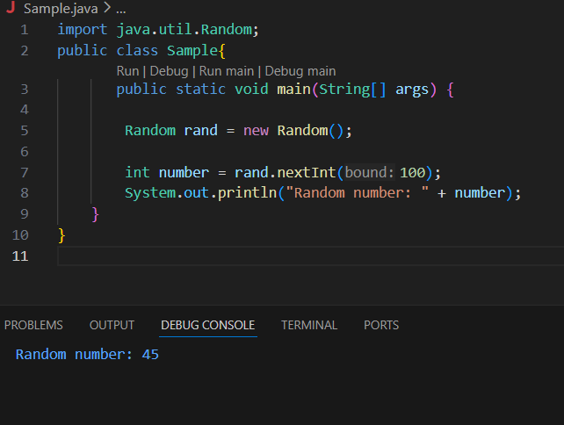
User-defined Packages are the packages that are defined by the user.
Source code
package com.myapp;
public class Helper {
public static void show() {
System.out.println("Hello from Helper!");
}
}
==To use this in another class==
import com.myapp.Helper;
public class Test {
public static void main(String[] args) {
Helper.show();
}
}

Output:
Hello from Helper!
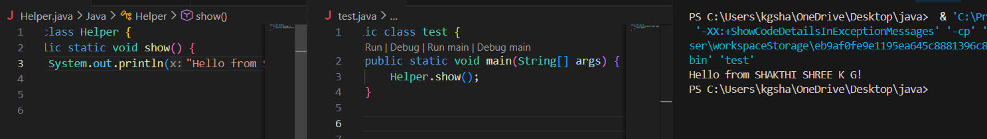
Source code
import java.util.Vector;
public class Coders {
public Coders() {

Vector v = new Vector();
java.util.ArrayList l = new java.util.ArrayList();
l.add(2);
l.add(5);
l.add(8);
System.out.println(l);
}
public static void main(String[] args) {
new Coders();
}
}
Output
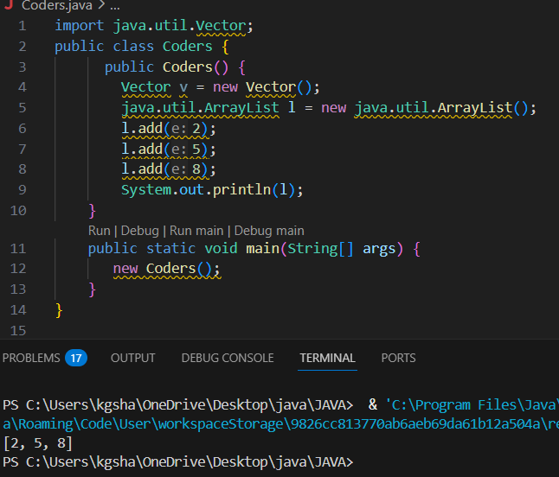
POST LAB EXERCISE
- What will happen if two classes in different packages have the same name and are imported in a Java file?
- It creates a name conflict (ambiguity).
- The compiler cannot identify which class to use.
- This results in a compile-time error.
- To solve it, use the fully qualified class name (package name + class name).

- What is the purpose of using packages in Java?
- To organize related classes and interfaces into a single unit.
- To avoid naming conflicts.
- To provide access protection (security).
- To support code reusability and easy maintenance.

- Which built-in Java package would you use if you want to create a GUI window and display a message?
- java.util
- java.sql
- java.awt
- java.net
Correct Answer: C. java.awt
- It is used for creating GUI applications.
- Provides components like Frame, Button, Label.
- Used for window-based applications.
- Handles graphics, layout, and events.

ASSESSMENT

Description | Max Marks | Marks Awarded
Pre Lab Exercise | 5
In Lab Exercise | 10
Post Lab Exercise | 5
Viva | 10
Total | 30
Faculty Signature

